Cartumo Tasks

1. Move BUMP button and option from product page to checkout page and put button left of the overview button.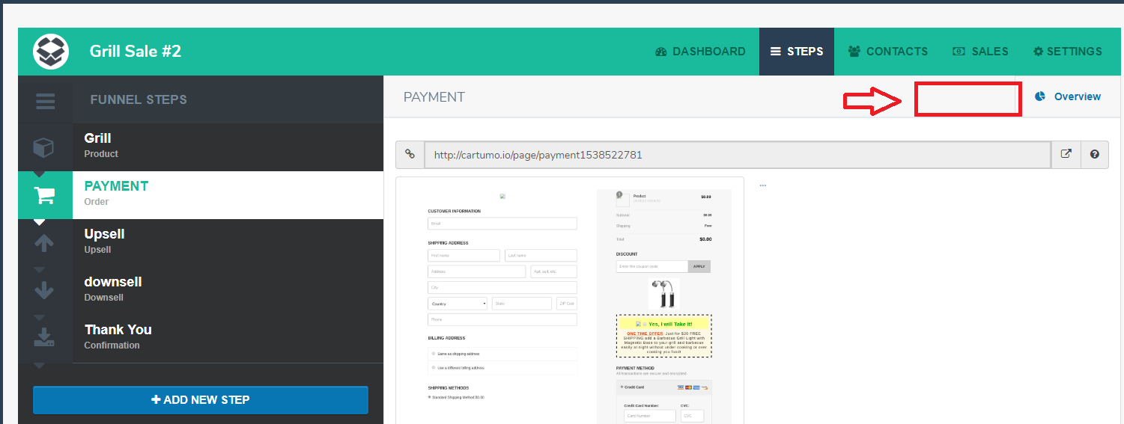

2 Make sure funnel clone and step clone work

Funnel Clone should let users clone the whole funnel template so they can use for another funnel.

Step Clone should be used for cloning just one step such as confirmation page, upsell etc.

3.. Fix all steps themes some don't show or they have no names for the themes.

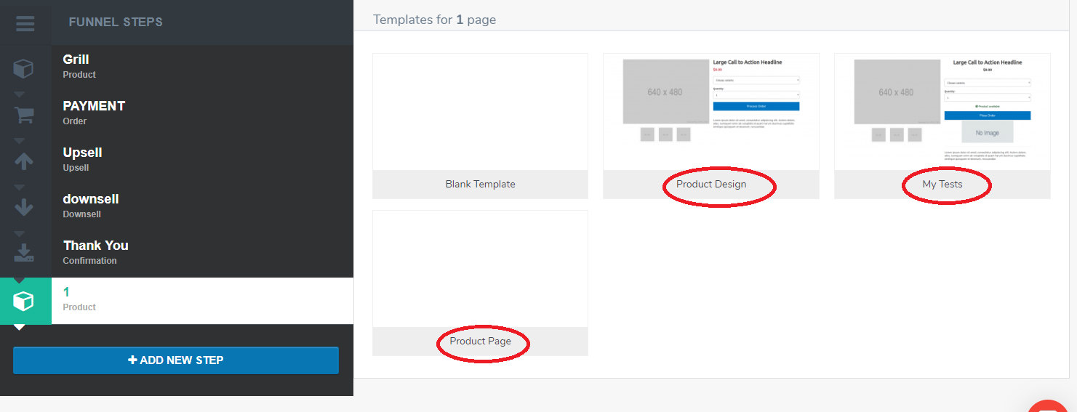

6. Fix SSL issue for the website also all users URLs should be SSL as well

7. Add CNAME Feature to each user. User can add their personal domain to the website. In ADMIN there should be a limit admin can do depending on the package.

8. Make sure shipping feature is working on checkout funnel page.

9. Users can share funnels with each other using the email address of the paid user. Add a checkmark box on the left of each funnel and on bottom an option share funnel

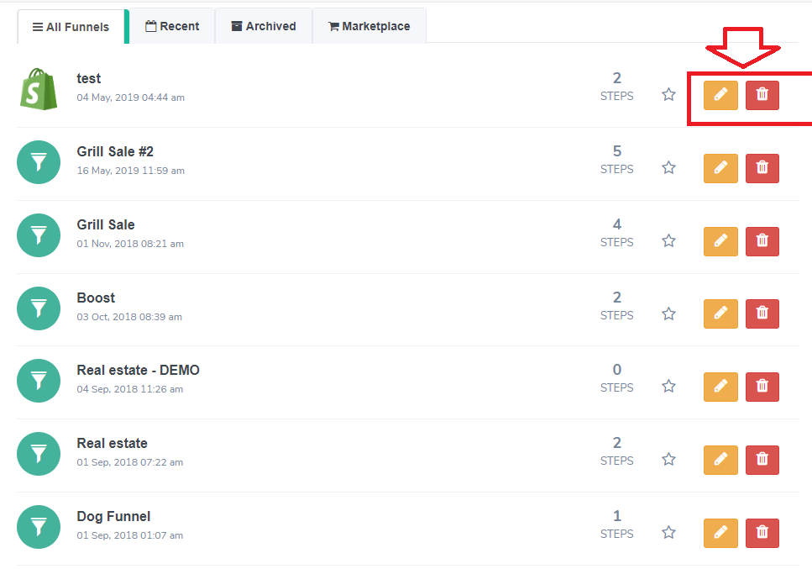

10. ADMIN page should be able to upload new templates for any step from backend for users to use.

11. ADMIN Should be able to choose how many funnels, upsells and downsells users can have to depend on the package.

12. Fix affiliate part in ADMIN where admin knows when purchased and shows how much payment needed to give every 30 days. Also, have a way to click the button to pay to affiliate PayPal address.

13. Add a better chat feature where can be used on mobile plus in the future can add more agents.

14. ADMIN Needs to look and work better for all features some stuff not needed and some stuff missing. Also, delete admin Sourav from the system he is the old developer and picture from the homepage.

15. A/B Split testing on funnel

16. Integrate zapier and woo commerce